**ASSIGNMENT-7**

U19CS012

**1.** Determine and plot the output voltage waveform for the given circuits. Also verify the same using Multisim.

Circuit a.)



A.) Multisim Calculations:

*1.) Circuit Image:*

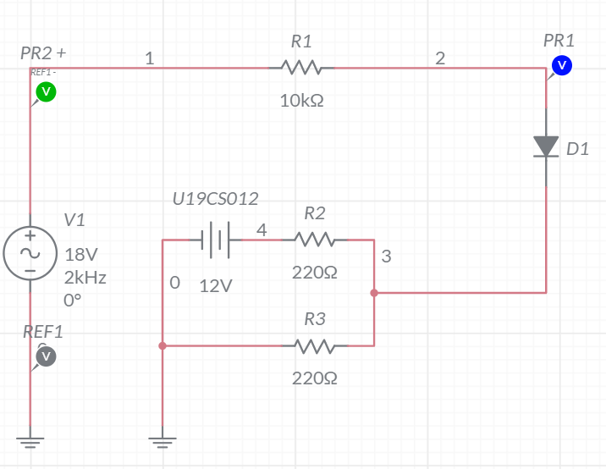

*2.) Grapher Image:*

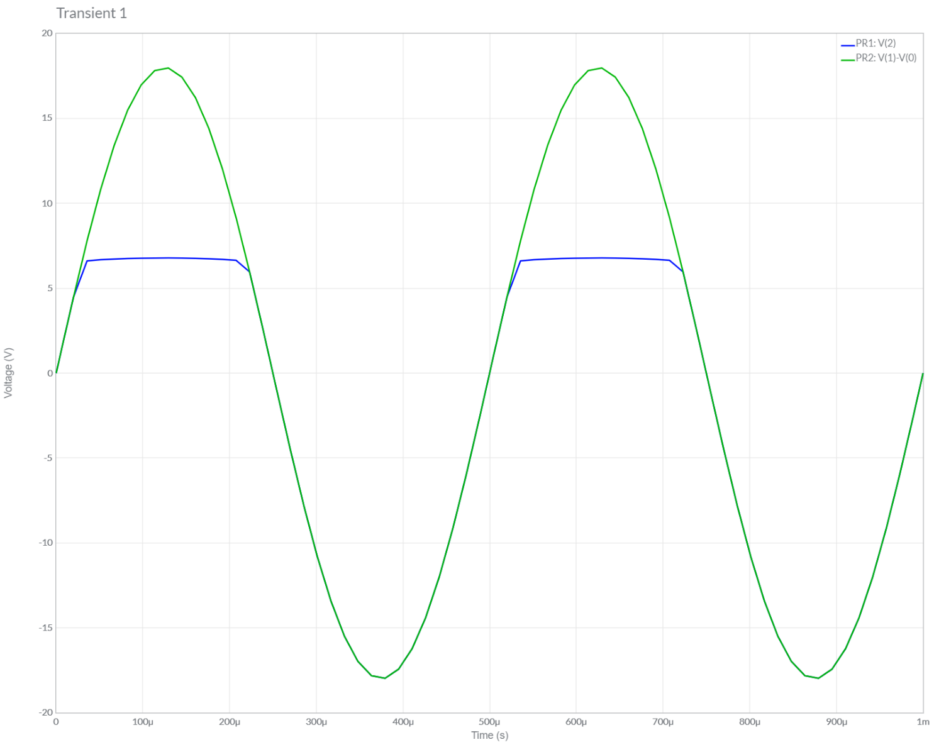

B.) Theoretical Calculations:



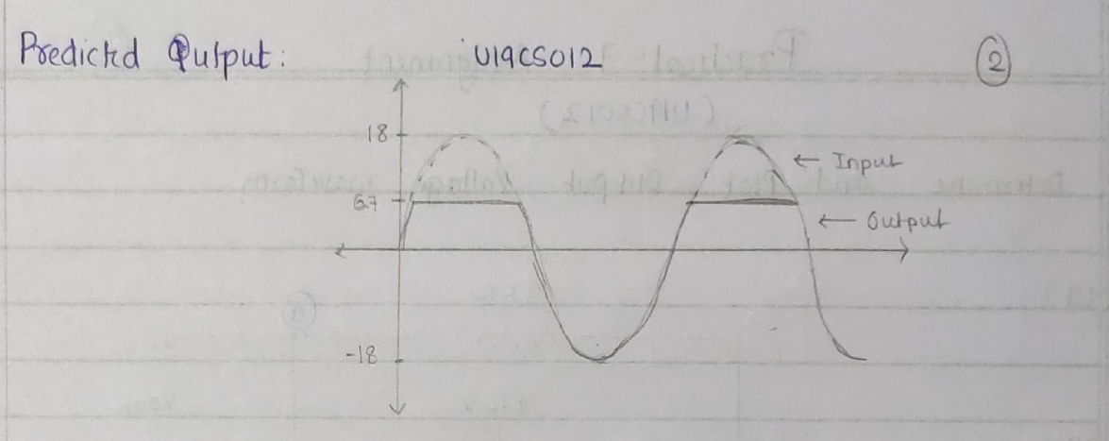

Circuit b.)

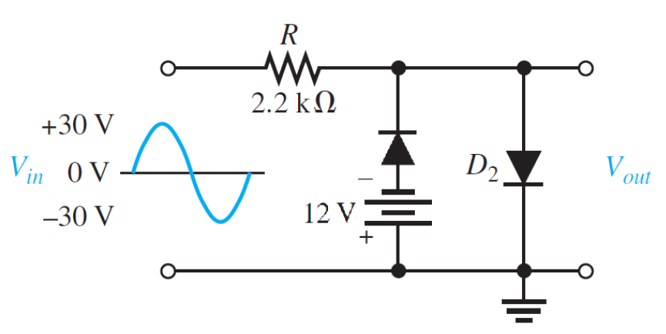

A.) Multisim Calculations:

*1.) Circuit Image:*

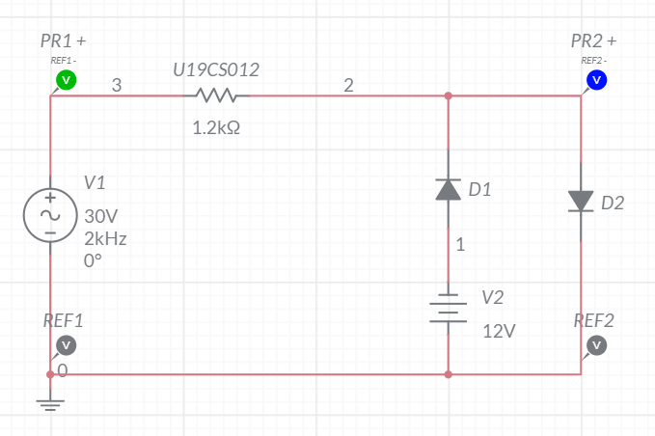

*2.) Grapher Image:*

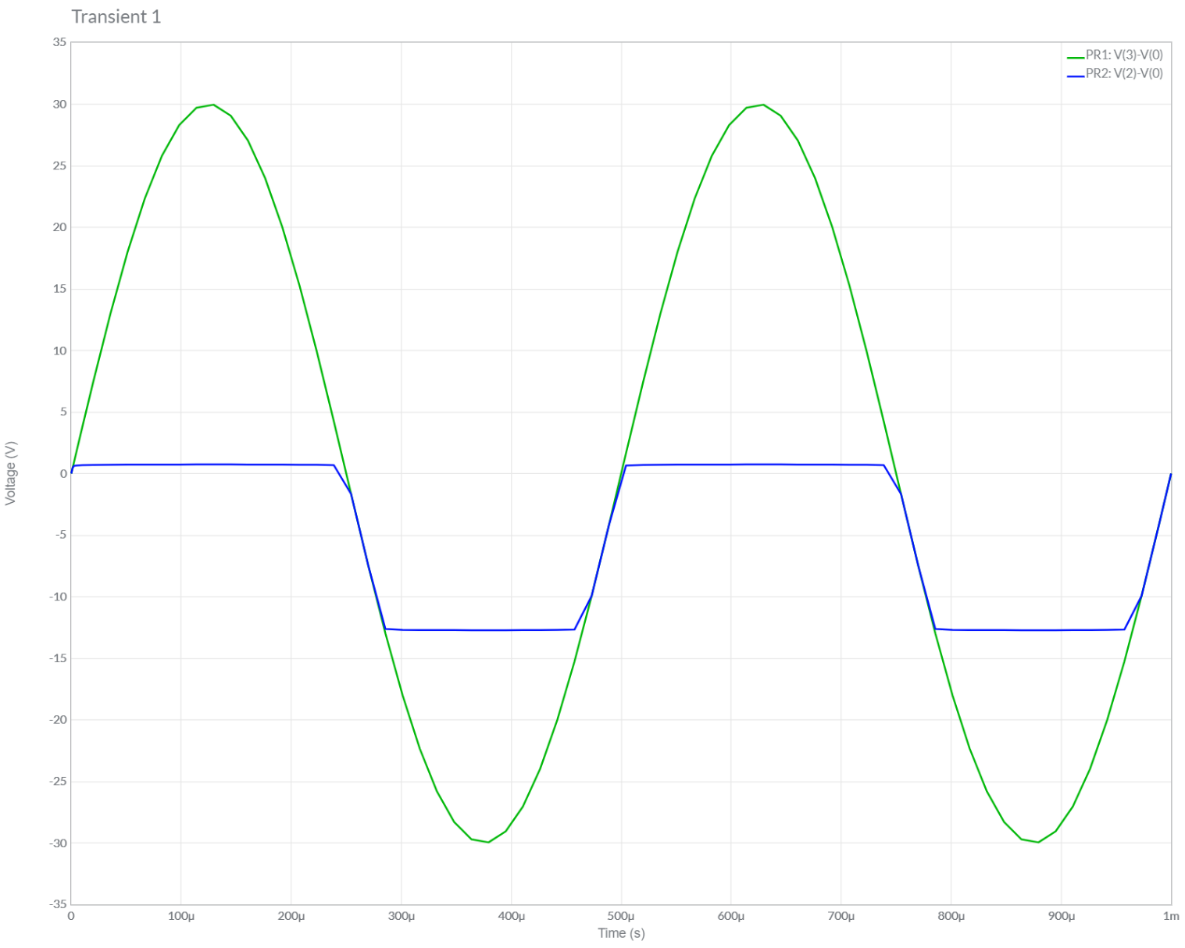

B.) Theoretical Calculations:

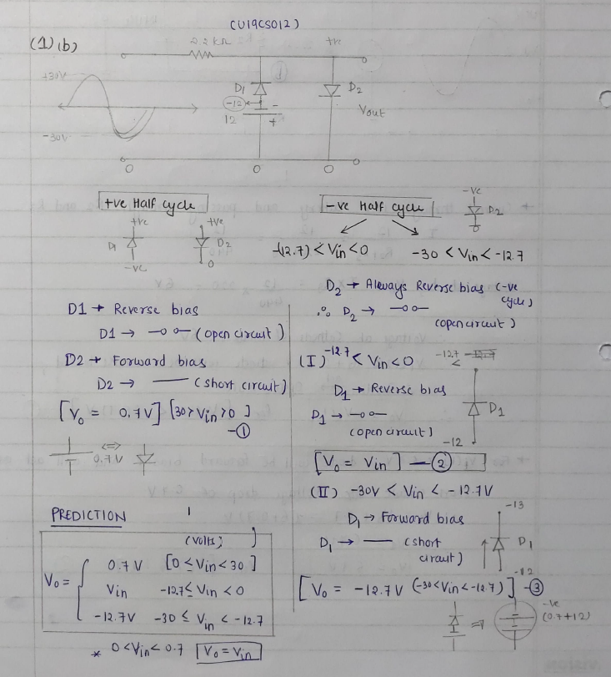

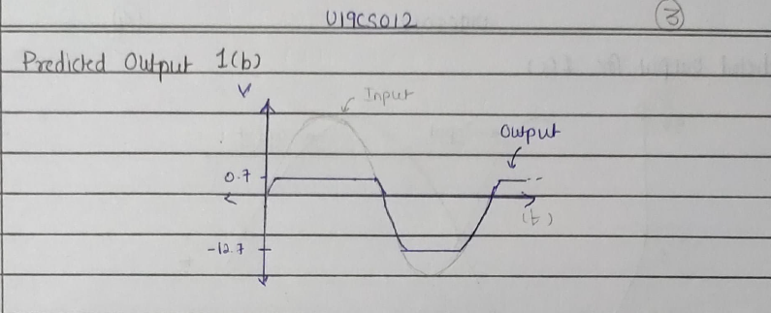

Circuit c.)



A.) Multisim Calculations:

*1.) Circuit Image:*

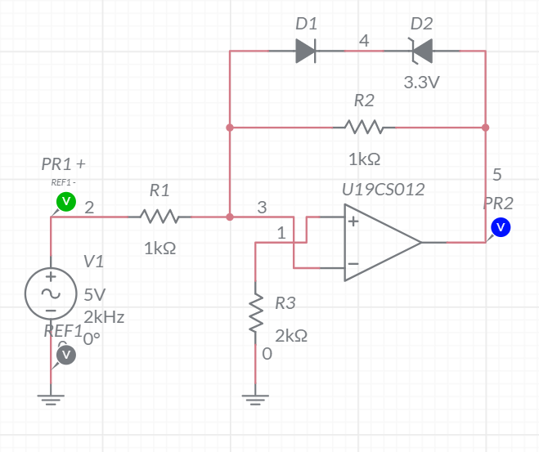

*2.) Grapher Image:*

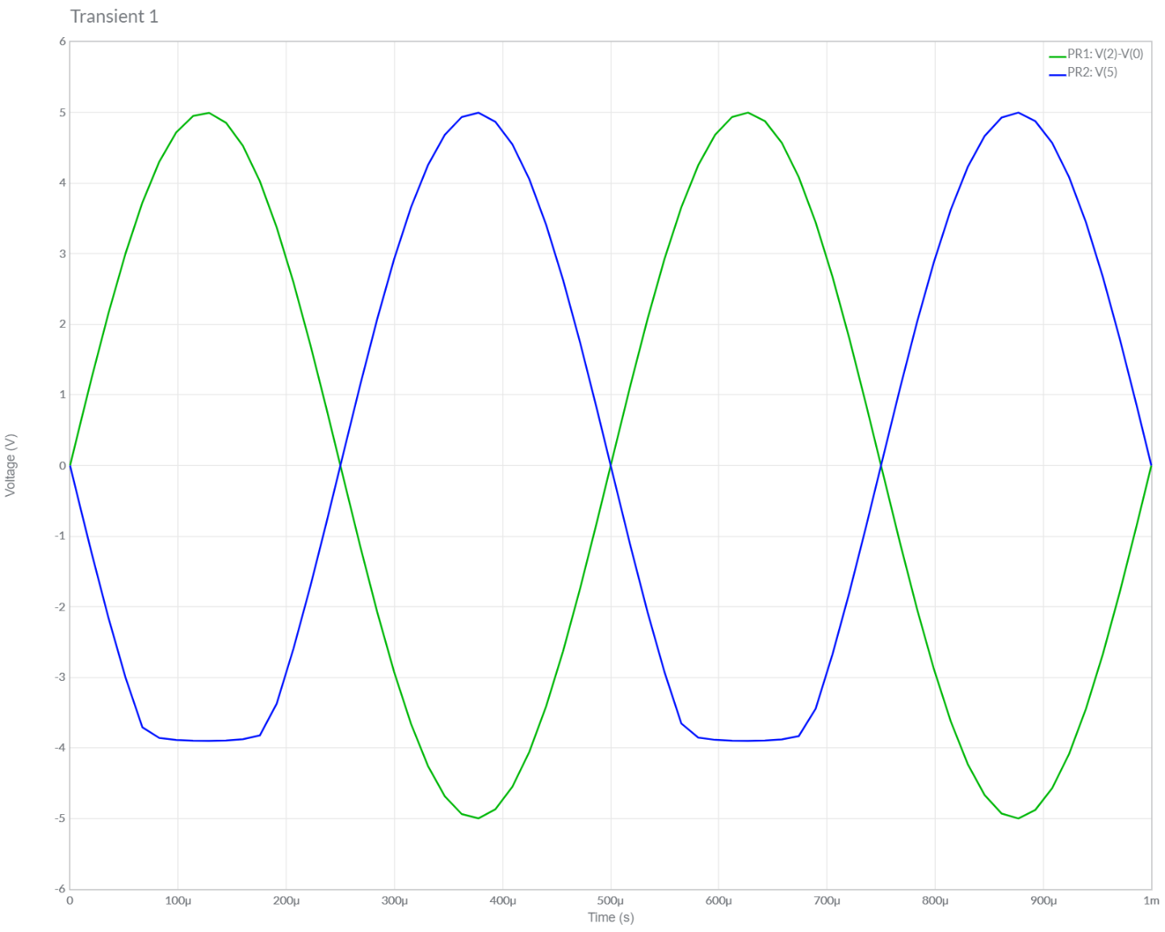

B.) Theoretical Calculations:

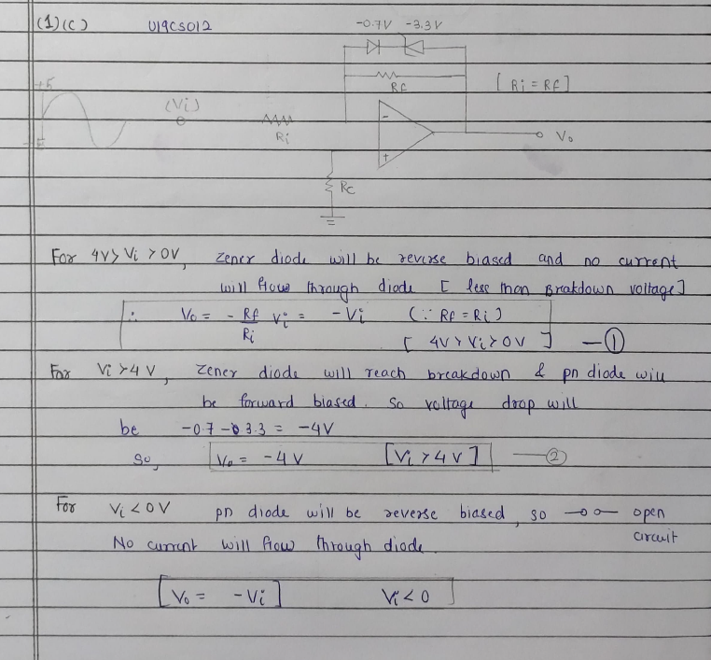

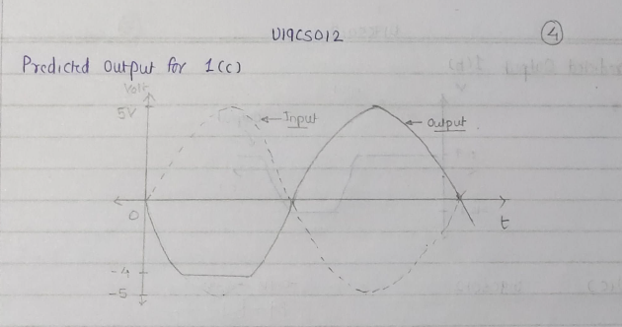

**2.** Draw the transfer characteristics for all the clipper configurations which are part of your today’s practical (Practical – 7).



**3.** Assuming Symmetrical Sine wave input with peak value greater than the Zener reference voltage, predict the output and plot the Transfer Characteristics for the following Clipper Circuits:



A.) Multisim Calculations:

*1.) Circuit Image:*

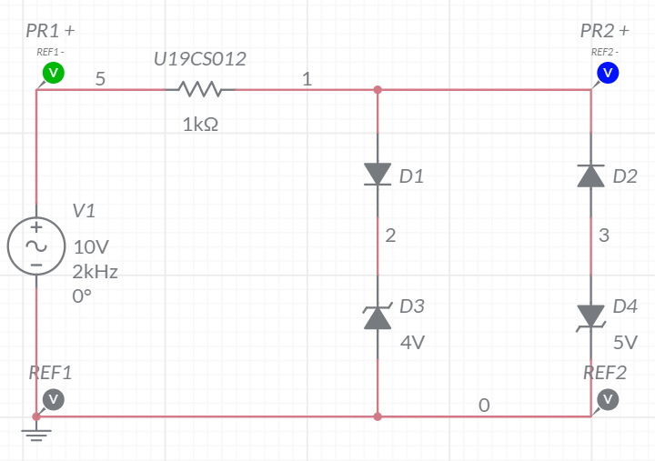

*2.) Grapher Image:*

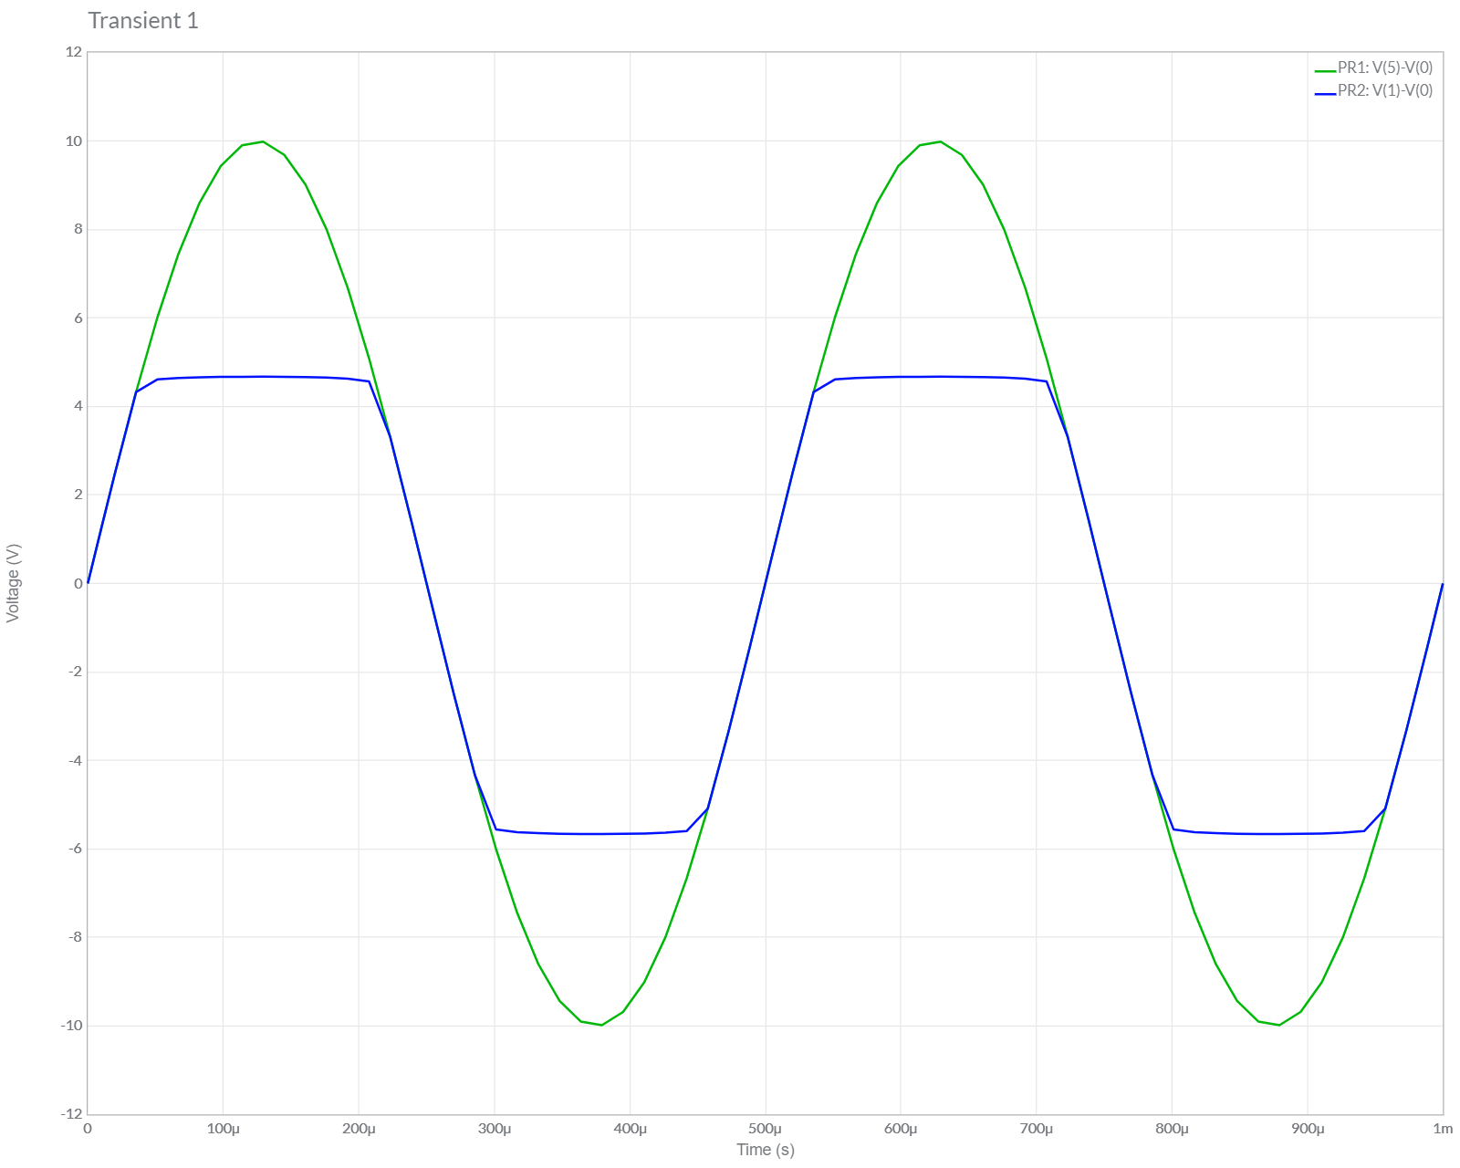

B.) Theoretical Calculations:

